

[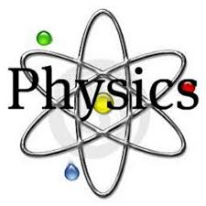](https://www.google.co.uk/imgres?imgurl=https://pbs.twimg.com/profile_images/2821633714/ea74608b616cb0dc06a2562c01dcbe2e_400x400.jpeg&imgrefurl=https://twitter.com/physicstweet&docid=ms6AJ0ds7o-yCM&tbnid=g1Pep2CwJ-UboM:&vet=10ahUKEwj3jbjQ6v3UAhVkKMAKHbnRC5YQMwjuASgOMA4..i&w=400&h=400&bih=673&biw=1366&q=physics%20images&ved=0ahUKEwj3jbjQ6v3UAhVkKMAKHbnRC5YQMwjuASgOMA4&iact=mrc&uact=8)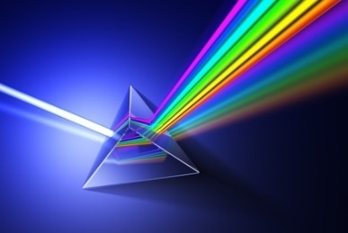

**Physics A LEVEL**

**Course handbook**

**2024/2025**

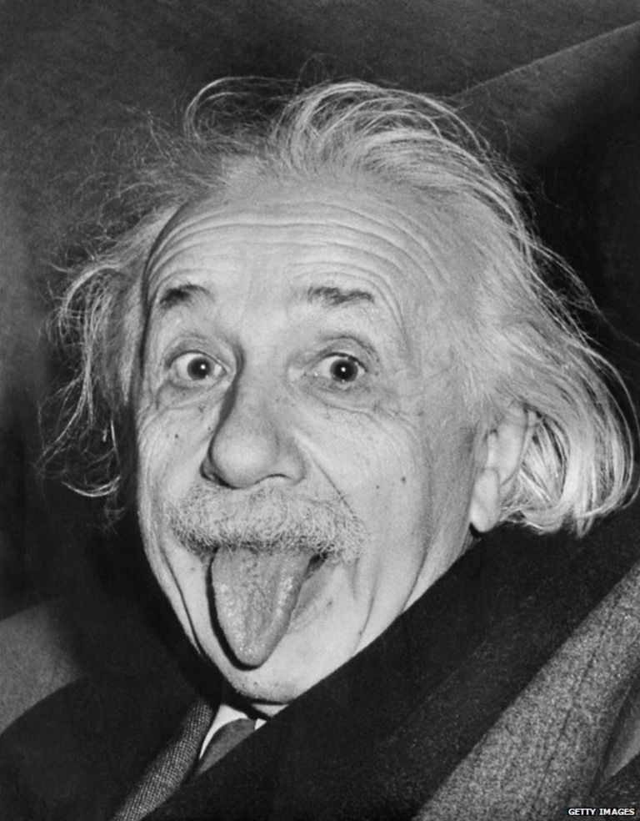

**Course outline with key assessments**

|  |
| --- |
| The specification can be accessed here(OCR Specification) and it is strongly advisable to have a copy to refer to in addition to your checklists:  <http://www.ocr.org.uk/qualifications/as-a-level-gce-physics-a-h156-h556-from-2015/>  The course is split into distinct areas with different teachers taking responsibility for certain parts of the modules as outlined in the table below. |

**HOW THE COURSE IS DELIVERED**

The course is delivered in laboratories, typically by 2 specialist members of teaching staff, sharing the course content and practical skills in proportion to teaching. The course is broken into 6 Modules with subsidiary units, most of which have a mathematical requirement which varies from unit to unit. Key mathematical skills learned in GCSE are expected to be fluidly applied with some natural extension of skills.

Practical work is assessed as shown below in a stand-alone qualification where the emphasis is on building practical skills of executing and recording work with an examined content in the exams at the end of the course. In lessons students will be either working individually, in pairs and in groups for both practical and theoretical tasks.

The Assessment Objectives, are split into 3 areas:

AO1: Demonstrate knowledge and understanding of scientific ideas, processes, techniques and procedures.

AO2: Apply knowledge and understanding of scientific ideas, processes, techniques and procedures:

* in a theoretical context
* in a practical context
* when handling qualitative data
* when handling quantitative data.

AO3: Analyse, interpret and evaluate scientific information, ideas and evidence, including in relation to issues, to:

* make judgements and reach conclusions
* develop and refine practical design and procedures.

These are allocated 31-34%, 40-43% and 25-28% of the overall marks in the A Level examinations respectively.

Integrated in the course are revision, consolidation, extension and regular testing lessons. Personalised Learning Checklists (PLCs) with links to the A Level Physics Specification should be reflected upon to gauge progress and feed forward. As the theoretical content of the course is fully examined a lot of emphasis is put on Exam Style questions where students work through previous exam questions and develop effective exam technique.

The use of links to university and industry is being constantly re-assessed and a range of experiences are fitted in to the course to complement and highlight different avenues available. Headstart courses, Gold CREST awards and Year in Industry are all extra-curricular activities students can access as well as school organised activities.

Course Text books: Students will have access to an E-Book via KERBOODLE which not only allows access on many platforms but contains a range of revision resources and questions and extension task to assist learning beyond reviewing the course content. There are also books which may be used in school but not taken away.

The paperback version of the text books are:

|  |  |  |
| --- | --- | --- |
| Title | ISBN | Price on Amazon |
| A level Physics for OCR Year 1 & AS | **ISBN-13:** 978-0198352174 | £25.77 |
| A level Physics for OCR Year 2 | **ISBN-13:** 978-0198357667 | £27.88 |
| A level Physics for OCR (combined for the above) | **ISBN-13:** 978-0198352181 | £41.99 |
| A level Physics for OCR A Revision Guide | **ISBN-13:** 978-0198352204 | £14.99 |
| CGP - A Level Physics Exam practice workbook | **ISBN-13:** 978- 1 78294 925 1 | £10.99 |
| CGP - New A-Level Physics: OCR A Year 1 & 2 Complete Revision & Practice with Online Edition (CGP A-Level Physics) | **ISBN-13:** 978-1789080391 | £14.98 |
| CGP Essential Maths Skills for A-Level Physics | **ISBN-13:** 978-1782944713 | £7.33 |

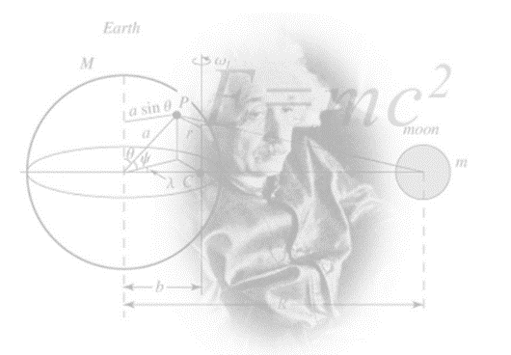

**Overview of A Level in Physics A (H556)**

|  |  |  |
| --- | --- | --- |
| **Content Overview** | **Assessment Overview** | |
| Content is split into six teaching modules:   * Module 1 – Development of practical skills in physics * Module 2 – Foundations of physics * Module 3 – Forces and motion * Module 4 – Electrons, waves and photons * Module 5 – Newtonian world and astrophysics * Module 6 – Particles and medical physics | Modelling physics (01) 100 marks 2 hours 15 minutes written paper **assesses content from modules 1, 2, 3 and 5.** | **37%**  of total A level |
| Exploring physics (02) 100 marks 2 hours 15 minutes written paper  **assesses content from modules 1, 2, 4 and 6.** | **37%**  of total A level |
| Unified physics (03) 70 marks 1 hour 30 minutes written paper **assesses content from all modules (1 to 6).** | **26%**  of total A level |
| Practical endorsement in physics (04)* (non-exam assessment) | Reported separately (see Section 5h) |

**A LEVEL PHYSICS DEPARTMENTAL EXPECTATIONS**

* Students are expected to purchase a working file in order to record and organise any notes and worksheets used in lessons.
* Students are expected to have the correct stationary for the lessons including pens, pencils, SCIENTIFIC CALCULATOR, scissors, glue and highlighters.
* Students are expected to attend all lessons.
* As the lessons involve a lot of theoretical and practical work and Exam Style Questions being used at home and in lessons, it is expected that students will complete all home study tasks to a high standard and these must be handed in on time.
* Students should be aiming to read around the subject and further their knowledge of Physics applications or theories beyond the curriculum.
* MISSED LESSON CONTENT DUE TO ABSENCE – Students are expected to catch up in their designated study periods (work is shown to teacher upon arrival to the next lesson)
* ONE GRADE BELOW TARGET IN ANY ASSESSMENT/HSTUDY – Student produces some revision or review work to assist understanding
* POOR QUALITY OF HOME STUDY – This will not be accepted and a PHYSICS supported study will be triggered
* Students are expected to pre-read the PAG method sheet and write up practical work and submit for marking according to the PAG criteria sheet stuck in with the practical

**HOME STUDY STRUCTURE**

**For every hour of lesson, it is expected students dedicate an hour to independent study time. Home study will be set using the following sections:**

**Gaps to close** – You act upon feedback, close the gaps in your learning e.g. writing a summary, re-answering test questions underperformed in, producing a glossary of key terms, mark scheme mnemonics, re-reading and extending lesson notes, practice testing, creating a model answer or mark scheme for areas struggling in, address PLC gaps etc.

**Revision** – Creating revision resources based upon what was taught in the lesson. E.g. Mind Map, Flash Card, lists, learning key word definitions.

**Assessed Designated Study Tasks** – Teacher set tasks which will be self/peer/teacher assessed depending upon what the teacher directs. These tasks are to be completed in Designated Study time and reflected upon in DIRT/ Starter Tasks once the deadline has passed. This could also include a flipped learning task (See P below)

**Support** – Identify areas from PLCs that may need teacher/peer support or extension after strategies have been tried to grasp the content.

Please take responsibility for making sure you ask for help if it is needed.

**Pre-work** - flipped learning – research undertaken ready for the next lessons content or extension work

**EXAMINATION PERIODS**

* Initial assessment in the first few weeks to allow students an insight into their suitability
* Internal progress check tests are integrated during the course, alongside homestudy and mock examinations
* Internal examination in March/April with additional testing/resits after half term to assist in UCAS applications
* Practical Assessment – on-going during the course to be written up and submitted as instructed (normally within a week)
* Examinations – May/June of Year 13



Below is a selection of books that should appeal to a physicist – someone with an enquiring mind who wants to understand the universe around us.

##### Moondust: In Search of the Men Who Fell to Earth

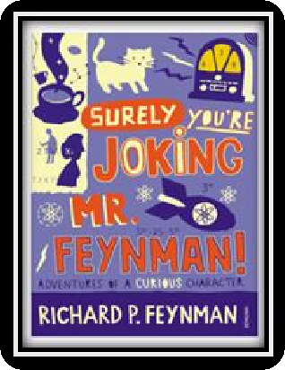

This book uses the personal accounts of 9 astronauts and many others involved in the space program, looking at the whole space-race era.

##### Surely You're Joking Mr Feynman: Adventures of a Curious Character

By reading this book you will get insight into his

life’s work including the creation of the first atomic bomb and his work in the field of particle physics.

##### Quantum Theory Cannot Hurt You: Understanding the Mind-Blowing Building Blocks of the Universe

Any physics book by Marcus Chown is an excellent insight into some of the more exotic areas of physics that require no prior knowledge.

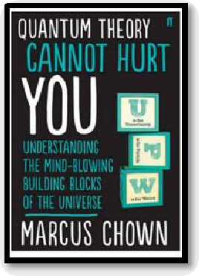

##### A Short History of Nearly Everything

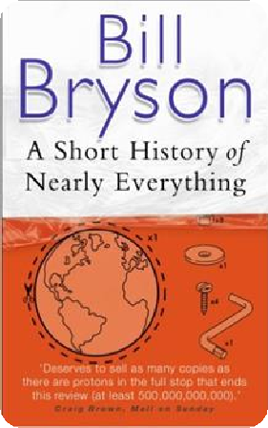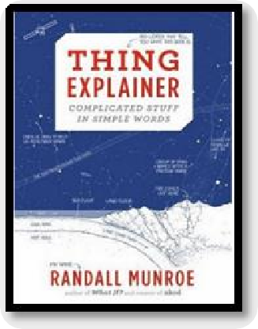

**Thing Explainer: Complicated Stuff in Simple Words**

Written by the creator of online comic XTCD (a great source of science humour) is a book of blueprints from everyday objects such as a biro to the Saturn V rocket and an atom bomb.

A whistle-stop tour through many aspects of history from the Big Bang to now. This is a really accessible read that will re- familiarise you with common concepts and introduce you to some of the more colourful characters from the history of science.

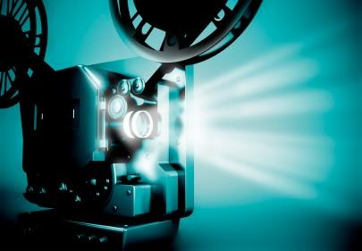

##### Moon (2009)

Everyone loves a good story and everyone loves some great science. Here are some picks of the best films based on real life scientists and discoveries. You won’t find Jurassic Park on this list! We’ve looked back over the last 30 years to give you our top 5 films you might not have seen before. Great watching for a rainy day.

With only three weeks left in his three year contract, Sam Bell is getting anxious to finally return to Earth. He is the only occupant of a Moon-based manufacturing facility along with his computer and assistant, GERTY. When he has an accident however, he wakens to find that he is not alone.

##### The Imitation Game (2014)

Based on a true story. During World War II, the English mathematical genius Alan Turing tries to crack the German Enigma code with help from fellow mathematicians.

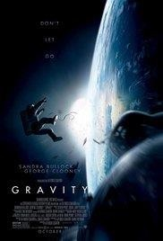

##### Interstellar (2014)

A team of explorers travel through a wormhole in space in an attempt to ensure humanity's survival.

##### Gravity (2013)

Two astronauts work together to survive after an accident which leaves them stranded in space.



##### Apollo 13 (1995)

Based on a true story. NASA must devise a strategy to return Apollo 13 to Earth safely after the spacecraft undergoes massive internal damage putting the lives of the three astronauts on board in jeopardy.

There are some great TV series and box sets available too! You might want to check out: Blue Planet, Planet Earth, Wonders of the Universe, Wonders of the Solar System, NASA TV and Shock & Awe – The Story of Electricity.

If you have 30 minutes to spare, here are some great presentations (and free!) from world leading scientists and researchers on a variety of topics. They provide some interesting answers and ask some thought-provoking questions. Use the link or scan the QR code to view:

##### From mach-20 glider to hummingbird drone

Available at: [https://www.ted.com/talks/regina_dugan_f rom_mach_20_glider_to_humming_bird_dr one/up-next?language=en](https://www.ted.com/talks/regina_dugan_from_mach_20_glider_to_humming_bird_drone/up-next?language=en)

"What would you attempt to do if you knew you could not fail?" asks Regina Dugan, then director of DARPA, the Defense Advanced Research Projects Agency. In this talk, she describes some of the extraordinary projects that her agency has created.

##### Is our universe the only universe?

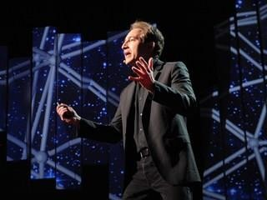Available at: [https://www.ted.com/talks/brian_greene_wh y_is_our_universe_fine_tuned_for_life?langua ge=en](https://www.ted.com/talks/brian_greene_why_is_our_universe_fine_tuned_for_life?language=en)

Brian Greene shows how the unanswered questions of physics (starting with a big one: What caused the Big Bang?) have led to the theory that our own universe is just one of many in the "multiverse."

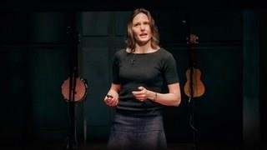**The fascinating physics of everyday life** Available at : [https://www.ted.com/talks/helen_czerski_ fun_home_experiments_that_teach_you_ physics?language=en](https://www.ted.com/talks/helen_czerski_fun_home_experiments_that_teach_you_physics?language=en)

Physicist Helen Czerski presents various concepts in physics you can become familiar with using everyday things found in your kitchen.

##### We need nuclear power to solve climate change

Available at : [https://www.ted.com/talks/joe_lassiter_we_n eed_nuclear_power_to_solve_climate_chang e?language=en](https://www.ted.com/talks/joe_lassiter_we_need_nuclear_power_to_solve_climate_change?language=en)

Joe Lassiter is focused on developing clean, secure and carbon-neutral supplies of reliable, low-cost energy. His analysis of the world's energy realities puts a powerful lens on the touchy issue of nuclear power.

**Physics** provides daily online-only news and commentary about a selection of papers from the APS journal collection. The website is aimed at the reader who wants to keep up with highlights of physics research with explanations that don’t rely on jargon and technical detail.



For one of the following topics, you are going to use the resources to produce one page of Cornell style notes.

Use the links or scan the QR code to take you to the resources.

##### Topic 1: Sizing up the top quarks interaction with the Higgs

Available at: <https://physics.aps.org/articles/v11/56> A proton collision experiment at CERN provides a

new handle on the Higgs boson’s interaction with the

heaviest of the quarks.

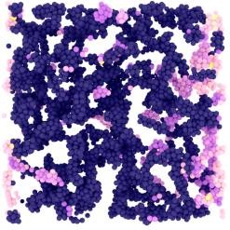Topic 2: **Why soft solids get softer**

Available at: <https://physics.aps.org/articles/v11/50>

Soft materials like gels and creams exhibit fatigue resulting from the stretching of their constituent fibres, according to experiments and simulations.

##### Topic 3: Listening for the cosmic hum of black holes

Available at: <https://physics.aps.org/articles/v11/36>

A new analysis technique would allow the gravitational-wave “background” from distant black hole mergers to be detected in days instead of years.

Potential Careers



